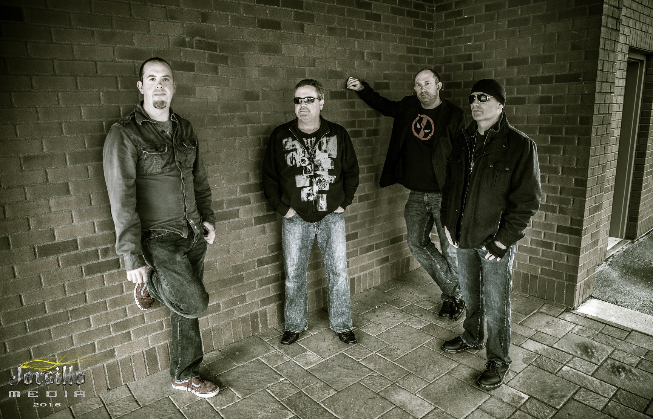

www.pastcurfew.band

Past Curfew is the Seattle area's hottest hard rock and alternative rock tribute band, performing all the radio-friendly hits audiences know and love. Our professionalism, enthusiasm for live performance, and faithful renditions of beloved songs earn us frequent praise from both audience members and venue staff alike. We keep crowds moving, dancing, and rocking out well past their bedtime, and we work hard to ensure we get invited back to play again!

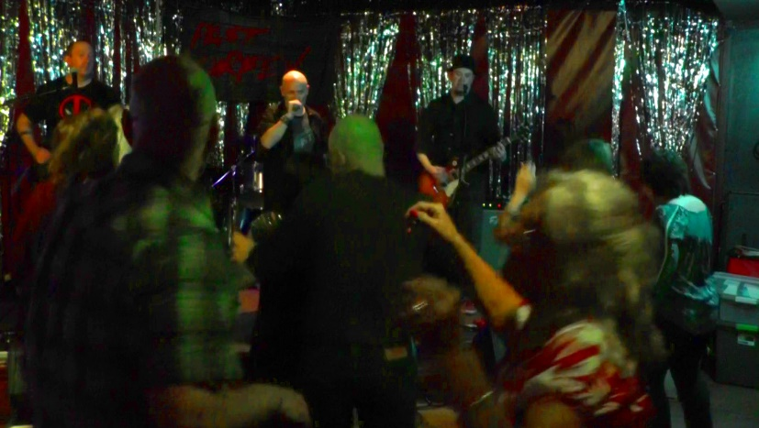 | 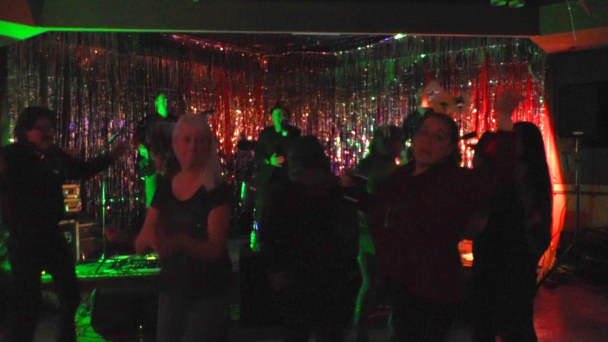
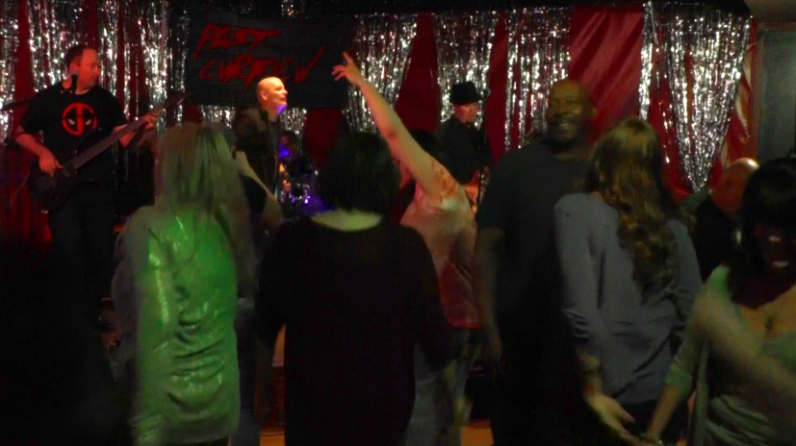 | 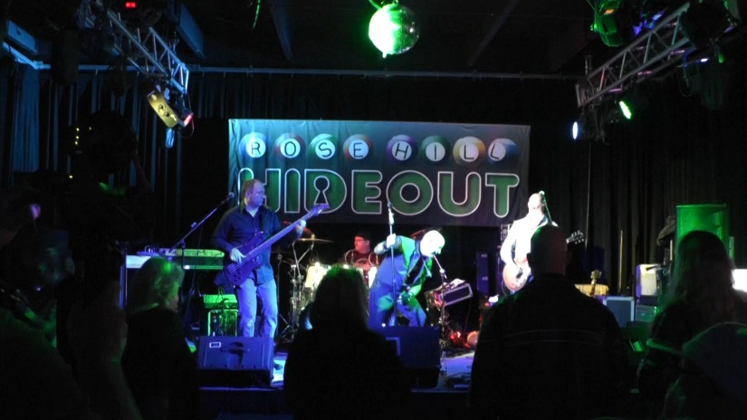

There’s a lot more to a gig than just showing up and playing music. It takes advance planning, relentless promotion (both online and offline), reliable high-quality gear, knowledge of live sound engineering, and a hundred other things. Whether the gig is a dive bar, a backyard house party, an outdoor festival, a corporate event, or a high-end casino with a huge stage and house sound, we have the experience, skills, and equipment to put on a successful and memorable show.

Find us on the web:
http://www.pastcurfew.band

Or check us out on Facebook:
http://www.facebook.com/pastcurfewband

For booking, contact Jeff Hall:
info@pastcurfew.band
425-478-0085

Some Previous Satisfied Customers
Rose Hill Hideout  Flights Pub  Balls & Whistles  907 Grill and Lounge  The Oxford Saloon  Snazzy Badger  Cliffhanger Sports Bar | Drift On Inn Roadhouse Casino  One-Eyed Jack’s Roadhouse  The Jet Bar & Grill  Super Bowl Pho Bar & Lounge  Sound Check Bar & Grill  Marco’s Restaurant & Lounge  …and various private parties

Past Curfew never plays the same show twice! We craft a unique set list to match the needs of each show, pulling from our ever-expanding catalog of recognizable, radio-friendly hits of the variety heard on stations such as Seattle’s own 99.9 KISW, 102.5 KZOK, or 107.7 The End.
A small sampling of our catalog:
3 Doors Down - Kryptonite  AC/DC - Highway to Hell  AC/DC - Thunderstruck  Aerosmith - Sweet Emotion  Alice in Chains - Man in the Box  Alice in Chains – Would  Big Data - Dangerous  Billy Idol - Rebel Yell  Billy Idol - White Wedding  Buckcherry - Crazy Bitch  Bush - Machinehead  Cheap Trick - I Want You to Want Me  Creed - Higher  Danzig - Mother  Finger Eleven - Paralyzer  Foo Fighters - All My Life  Foo Fighters - Learn to Fly  Green Day - American Idiot  Green Day - Welcome To Paradise  Guns N' Roses - Sweet Child of Mine  Jet - Are You Gonna Be My Girl  Jet - Cold Hard Bitch  Journey - Any Way You Want It  Led Zeppelin - Immigrant Song  Led Zeppelin - Rock and Roll  Lit - My Own Worst Enemy | Megadeth - Symphony of Destruction  Metallica - Enter Sandman  Nirvana - Smells Like Teen Spirit  Ozzy Osbourne - Crazy Train  Pearl Jam - Evenflow  Puddle of Mudd - Control  Radiohead - Creep  Rage Against the Machine - Bulls On Parade  Ratt - Round and Round  Rush - Limelight  Soundgarden - Outshined  Spacehog - In The Meantime  Stone Temple Pilots - Plush  Stone Temple Pilots - Sex Type Thing  The Black Crowes - Hard to Handle  The Cure - Just Like Heaven  The Offspring - Come Out and Play  Theory of a Deadman - Bad Girlfriend  Tom Petty - An American Girl  Tool - Sober  U2 - Vertigo  Van Halen - Hot For Teacher  Van Halen - Panama  Velvet Revolver - Slither  Violent Femmes - Add It Up  Wild Cherry - Play That Funky Music

Solon Scott - Lead vocals
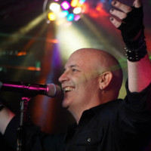
Solon likes to get up and after it! His high energy, electrifying style is all about making the fans have an amazing experience. Expect the unexpected, as he "explores the stage", "gets down with the crowd", or belts out an unexpected tune. No two shows are ever the same! He is proud to front Past Curfew as it allows him to continue to grow as an artist. Through the amazing musicians behind him and the choice of songs, he can try on a variety of sounds and styles while still delivering an entertaining performance. Previously he was the front man for Brigade, a hard rock and metal band. Before that, he was lead singer for Rewired, which did a variety of pop, rock, disco and country. Solon's motto is simple: "People like to party, I like to party with the people, so let's have a party!"

Nick Kurtz - Guitar and backing vocals
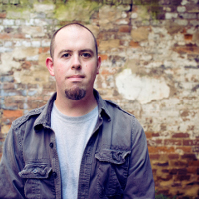
Hailing from Knoxville, TN, Nick Kurtz was irrationally obsessed with music ever since he could walk. He started playing guitar as a teenager, quickly garnering a reputation as one of Knoxville's taller guitarists. Nick spent many years on the original and cover circuits, sharing bills with numerous national acts and recording with local legend Don Coffey, Jr. of Superdrag fame. In 2015, in an effort to ascertain how far northwest a human being could move while remaining in the contiguous United States, he found himself in Seattle and joined Past Curfew. A music major, he's been known to give guitar lessons if provoked, and can be seen at shows channeling light and magic through his magnificently calloused fingertips.

Keith F. Kelly - Bass and backing vocals
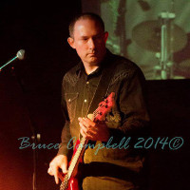
Keith took piano lessons as a child, but the music that moved him wasn't classical. During college, he started teaching himself to play bass after hearing bands like Faith No More, Primus, and The Red Hot Chili Peppers. After moving to Seattle in 1999, Keith joined The Soul Proprietors, a gigging soul and Motown cover band. Later, he formed and led an alternative rock cover band called The Morans, which ended up recording a cover of “Brick House” that ended up in the 2009 movie "Duplicity" starring Julia Roberts and Clive Owen. In 2010, Keith joined up with Seattle rock band 93 Octane, with which he performed frequently around the region for a few years. After parting ways with that band, Keith eventually assembled a new project which went on to become Past Curfew.

Jeff Hall - Drums
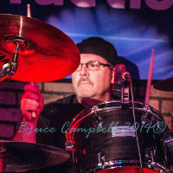
Jeff has been an Edmonds, WA resident since birth and has a long list of accomplishments to his name. He has recorded locally and takes a lot of pride in his craft. Jeff started playing the drums in the 7th grade, made the jazz lab band as a freshman at WSU, and played every club he could. He has studied both jazz history and music theory and learned from some of the Pacific Northwest's top instructors. Jeff gradually developed a passion for rock drumming, so he joined a rock band that played fraternity gigs and high school dances throughout the region, transferring his well-honed skills to a new and exciting style. Later, Jeff joined up with Seattle rock band 93 Octane, where he met Keith. After performing together a couple years, Keith and Jeff eventually left and formed their own project, which became Past Curfew. Jeff keeps the band rocking and grooving with his solid chops and easy-going style.

